

Quick Start Guide

Table of Contents
What’s in the Box 1
Get Started 1
Hardware Installation 2
For Mobile Device 2
Set Up Camera 6
Set Up Wi-Fi Without Network Cable 8
View in Windows Web Browsers 10
Frequently Asked Questions 14

What’s in the Box
- IP Camera
- DC Power Adapter
- Network Cable
- Mounting Bracket
- Quick Start Guide
- CD

Get Started
Hardware Installation

Add Camera

Get Live Video

Set Up Camera

Get Live Video via Wi-Fi

Hardware Installation
Router
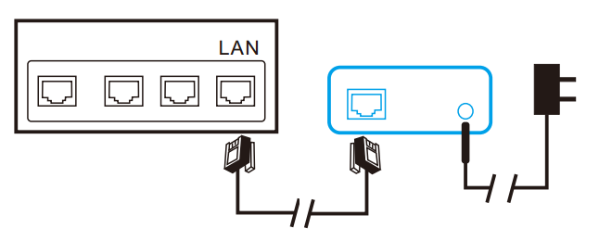
IP Camera

For Mobile Device
- Download iWFCam from App Store for IOS devices or from Google’s Play Store for Android devices. For easy installation, please scan the QR code to download and install iWFCam. If your android device cannot access Google’ s Play Store, please scan this QR code and select download APK directly.
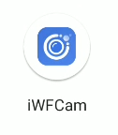

Download the QR code


- Tap on to add your new camera. Click Add new online Camera, and enter camera’s UID and password to add a new camera. When using the camera for the first time, please refer to Set Up Device Wi-Fi connection to set up the camera’s connection to your router and then add it to the device list.

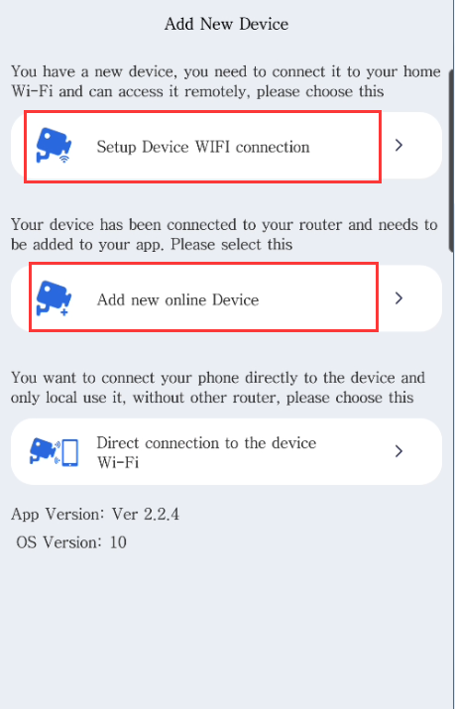

- There are 2 ways to enter the camera’s UID quickly, by scanning the QR Code on the camera and searching the cameras in LAN. Click QR Scan to initiate the scan and click Search(LAN) to search the cameras in LAN.
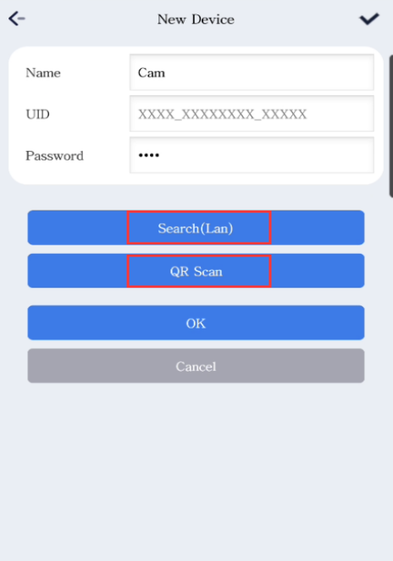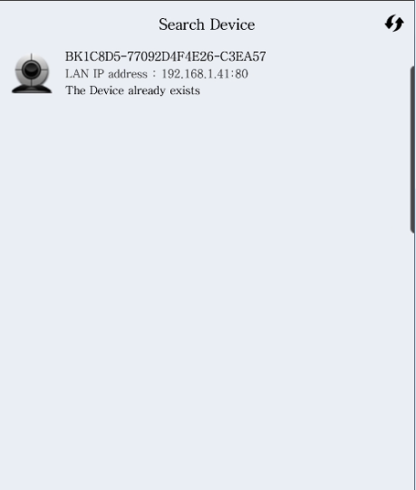

- Enter the camera’s name and its P2P password. By default the P2P password is 8888. After clicking OK, the camera will be added successfully.
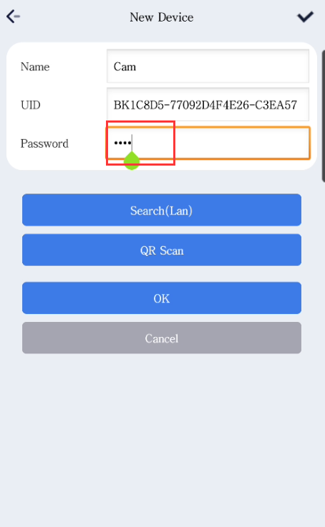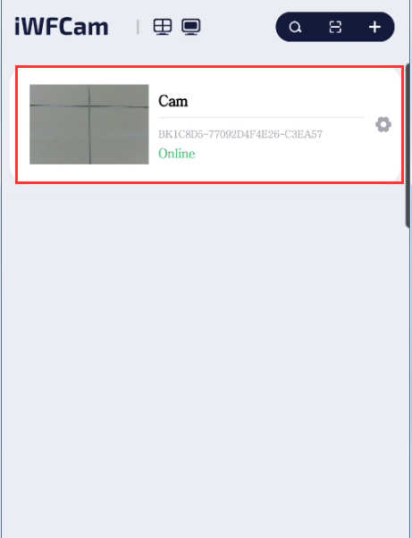

- Select the camera you have just added to start viewing live video. Tap on the black area to launch the control panel.

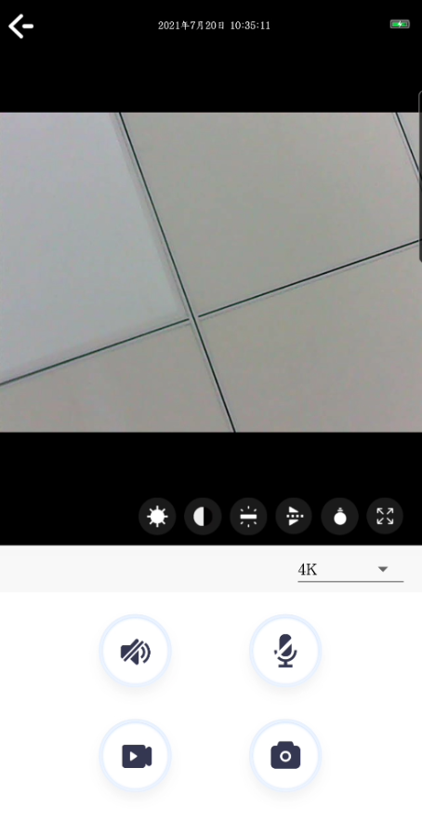

- Instruction for the icons and buttons on live video page:
Pan/tilt control | Slither the video to pan or tilt the camera
 | Allow users to listen to the camera’s audio feedback and talk to the camera.
 | Take snapshots and record video files.
 | Horizontal and vertical cruise.
 | Adjust the brightness and contrast.
 | Adjust the camera indicator and night vision

- Instructions for other pages:
 | View the current live video
 | View the screenshots and video files of your camera
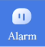 | View camera alarm event records
 | Check the version of the app
*Notice: This IP Camera is designed to only supplement existing residential and
business security systems.

Set Up Camera
- Press the camera item in the camera list for about 3 seconds to start configuring your camera.
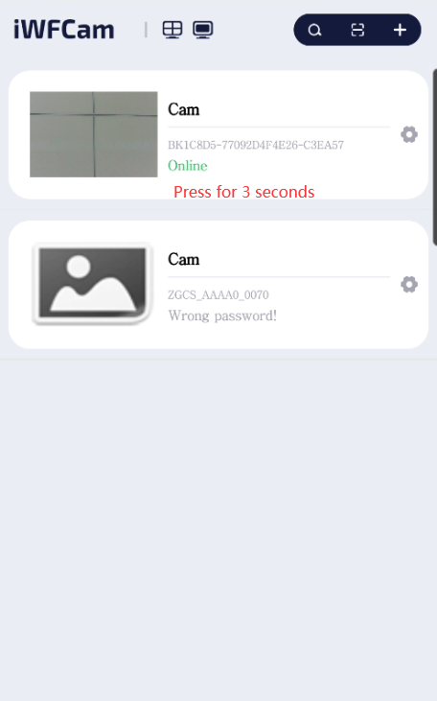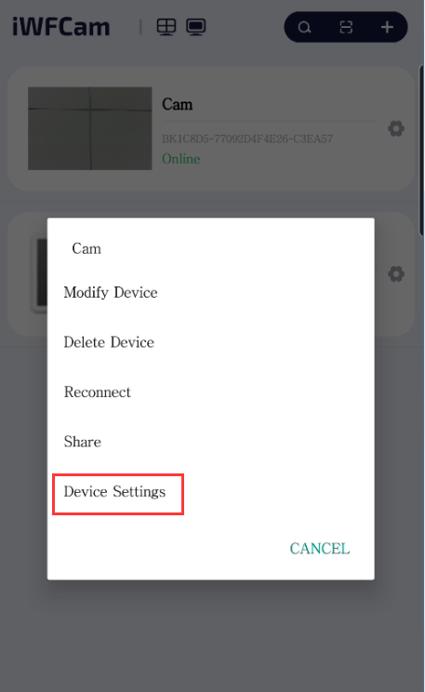
- The camera will start scanning for Wi-Fi connections. Select your Wi-Fi network ID (SSID). Enter the password for the Wi-Fi connection.
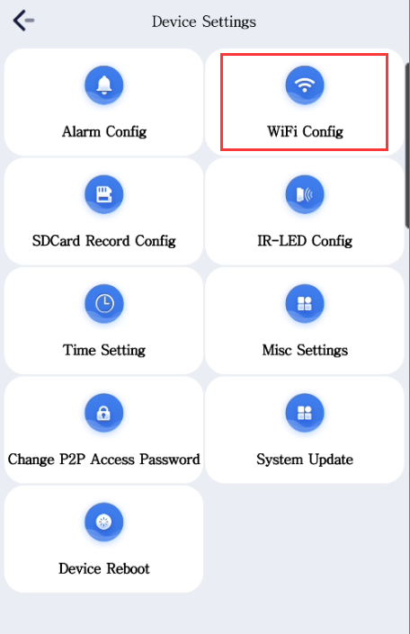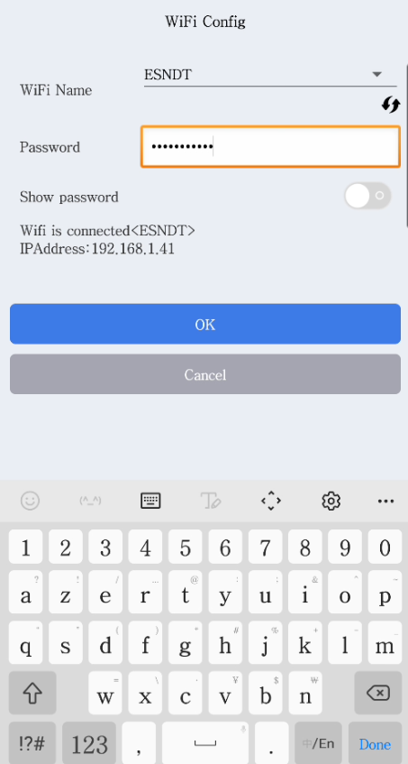
- When Wi-Fi is successfully configured, you can now disconnect the network current from your camera and start connect to the new Wi-Fi network.
*Notice: Please wait for at least 30s(maximum to 1 minute) for Wi-Fi mode to be completely functional.
- After setting up Wi-Fi, we can set up SD card recording mode.
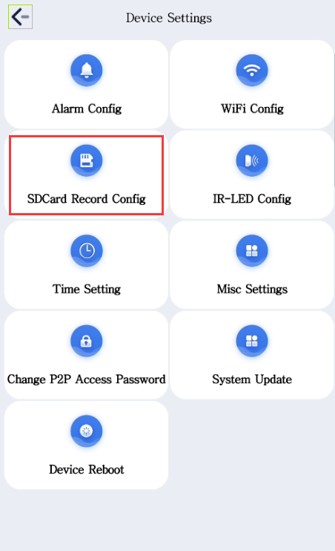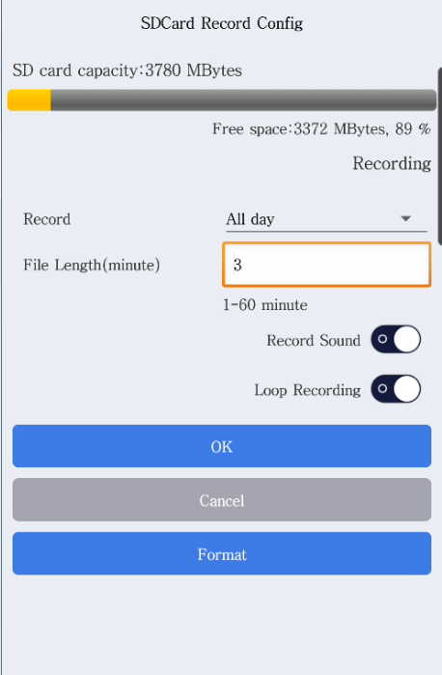
- Set up Alarm config to enable motion detection alarm.
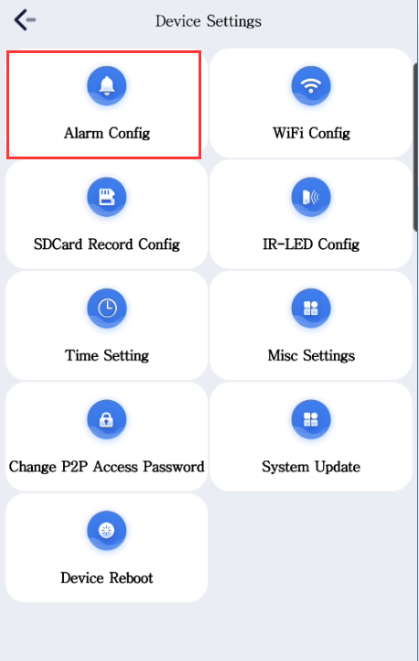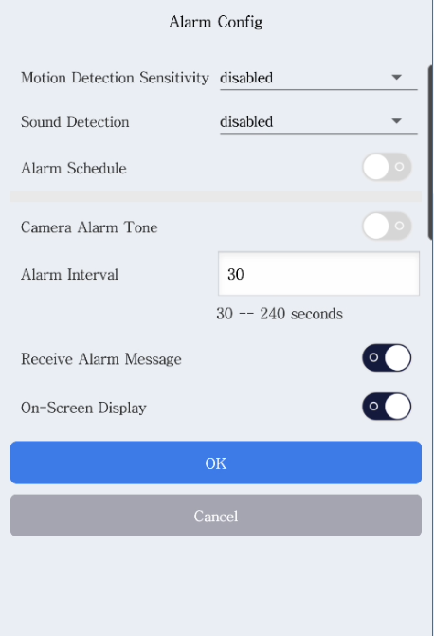

Set Up Wi-Fi Without Network Cable
*Tips
Please make sure your camera is in AP Mode before setting up Wi-Fi connection. AP Mode can be achieved by long pressing the reset button on the camera and wait for camera reboot.

- Go to “Settings” on your device and then tap on “Wi-Fi”, and then make your device connected to the network that has the same UID as the camera.

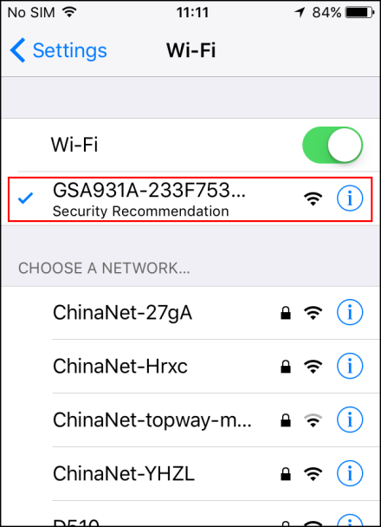

- Once the camera is in AP Mode, we can set up Device Wi-Fi connection to the camera. Tap on to add your new camera. Click Setup device WiFi connection.
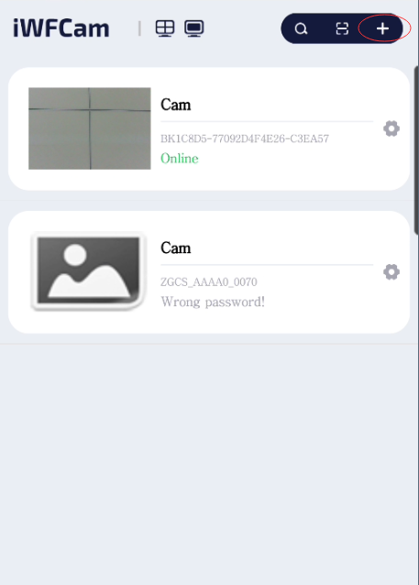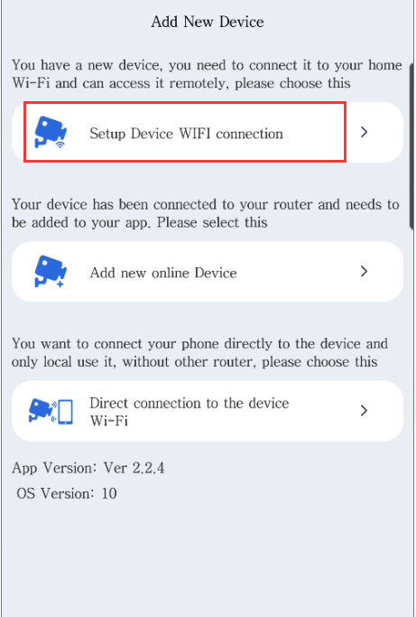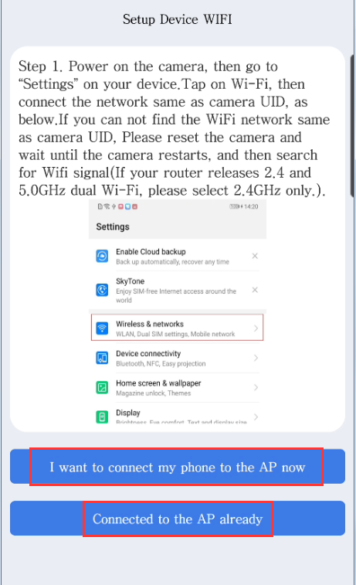

- Make sure of the specific network you want your camera connected to and the correct W-Fi password, and then click Start configuring WiFi.
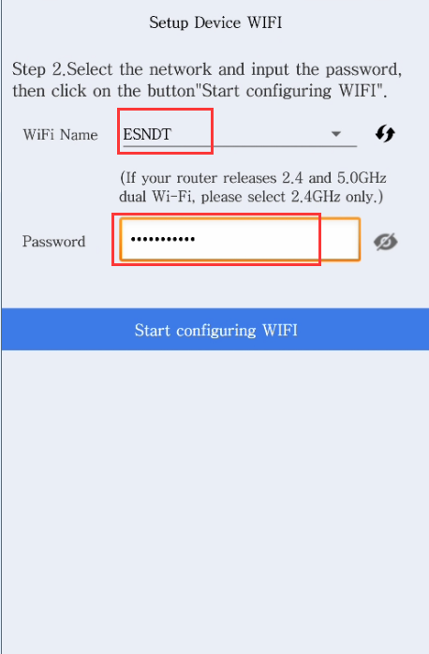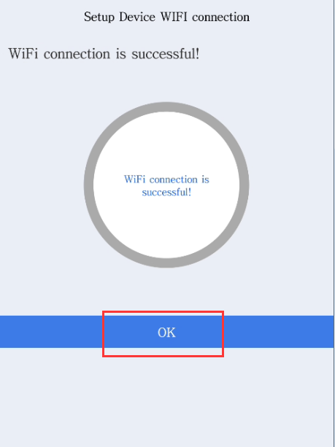
*Notice: 1: The current WiFi connection is not supportive of 5.0GHz Wi-Fi, so please make sure the network your camera is connecting to is a 2.4Hz one. 2: Not support WEP mode WiFi. 3: Not support hide SSID mode WiFi.

- Click【Save】to add the camera to the P2PCamera list after the status bar shows WiFi connection is successful.
*Notice: If the app always shows failure, please try close the camera to your router and camera dose not support HIDE SSID mode .

View in Windows Web Browsers(Only some models support)
- Run IP Camera Finder shown as IPCamera.exe in CD’s Windows folder. Double click the camera item listed in the camera list.
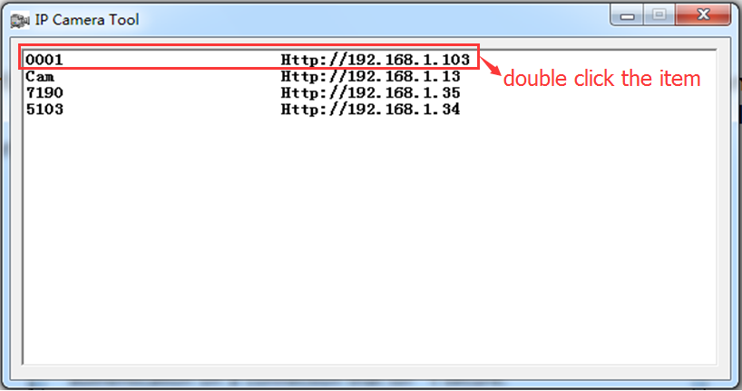
- The default web browser will try automatically logging into the camera. The default username is admin. There is no password by default, so leave the password field blank.

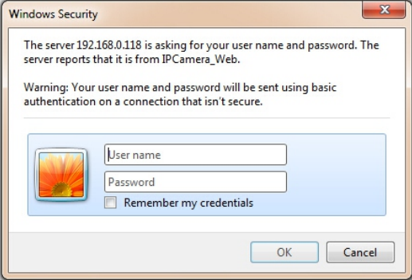

- Download web browser plug-in and install it to support playing live videos in Windows web browsers. Please ignore system warnings when downloading or installing the plug-ins.
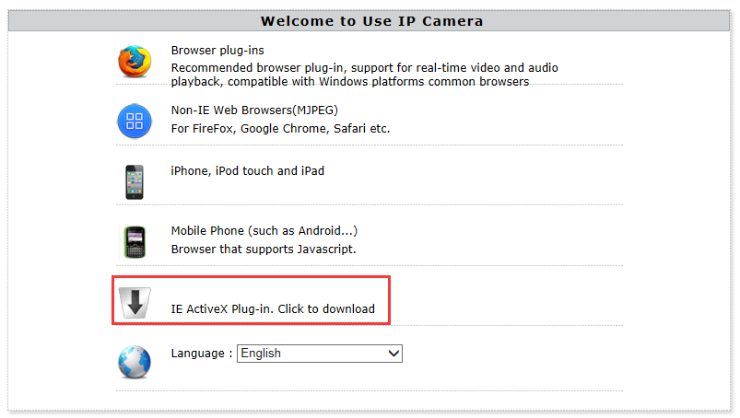

- After installing the plug-in, choose Browser plug-ins mode to get live videos.
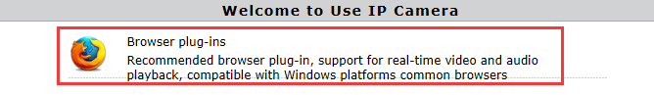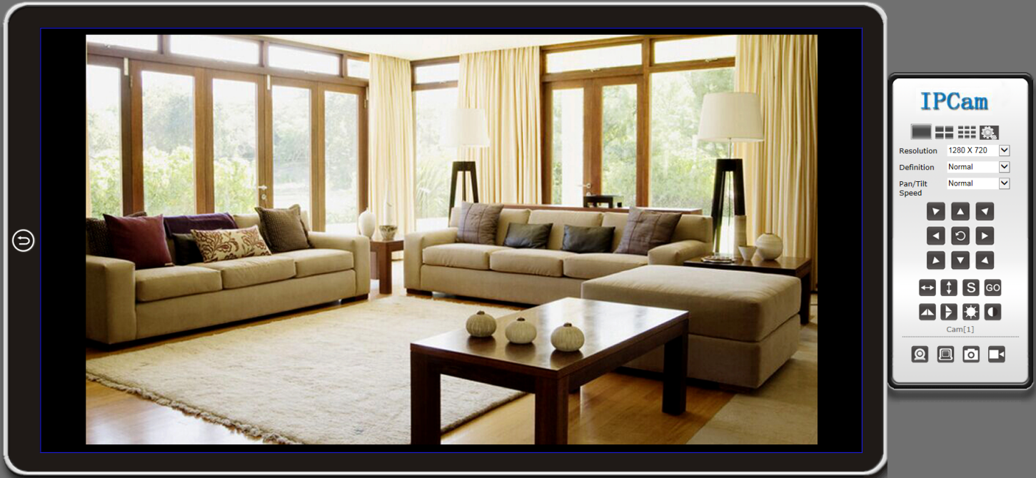

- Instructions for buttons on the panel.
 | Back to the welcome page
 | Single camera view mode
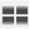 | 4 camera view mode
 | 9 camera view mode
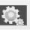 | Click the button for camera settings
Resolution | Change the video’s resolution
Definition | Change the video’s quality
Pan/Tilt Speed | Change the speed of Pan/Tilt
 | 8 direction keys and the center one is rotation center
 | The horizontal cruise will pan automatically
 | The vertical cruise will tilt automatically
 | Set preset position
 | Go to the specific preset position you have set
 | Invert the video horizontally
 | Invert the video vertically
 | Adjust the brightness of the video
 | Adjust the contrast of the video
 | Receive audio feedbacks from the camera
 | Send audio to the camera
 | Take snapshots with the camera
 | Record videos to PC

*Tips
What are preset positions?
Preset positions are IP camera’s memorized P/T positions. Once you set a preset position, you do not need to pan the camera to your preferred position. You simply press the preset button that corresponds to the preset you want to see and the camera will move to that position automatically.

Frequently Asked Questions
- What is the default password for the App access device？
The default password is "8888", Recommend that you modify the default password, Reset device can restore access password to default.
- Why the camera could not connects to Wi-Fi router, Or the connection is not stable?
Make sure your Wi-Fi SSID and password do not contain special characters and non-English letters. Change them in your wireless router if there are these characters. You would better only use numbers, English letters ...
Make sure Wi-Fi password is correct. It is case sensitive.
Make sure there are only one SSID which named as you choose.
Please choose a 2.4Ghz Wi-Fi network instead of a 5Ghz Wi-Fi network
Make sure your Wi-Fi security is WPA or WPA2 instead of WEP.
Make sure there are only one SSID which named as you choose.
Please do not locate the camera far away from your router. Any barrier between the camera and the router will affect network quality.
Restore your camera to factory default and try again.
- Why can’t the search tool detect the camera?
Please make sure the network cable (or WiFi) is connected. Turn off the firewall and security software on your computer. Make sure the camera is connected to the router instead of the computer.
- Why does the camera web always ask for username and password, or it says “incorrect user”?
The camera’s default username is [admin], and its default password is N/A, which means you just leave it blank. If you forget your username or password, you can reset the camera to factory settings to get the default username and password.
- Why can’t I get live video in web browser?
Please download and install plug-in before getting live video. If there is still no live video, check whether or not the plug-in is enabled in your web browser?
- How can I reset the camera to factory settings?
Please long press the reset button under or on the camera for about 3 to 5 seconds until the camera’s indicator is off. Please make sure the power supply is connected when you are doing it.
- Why can’t the camera record videos?
Please make sure you are running the web browser as an administrator. Right click the web browser and select Run as Administrator to run as an administrator. For android app, please insert a TF card into the camera before recording?
- Why is the image blurry?
Remove the protective film on the lens and rotate the lens of the camera to get a clear image.
- How can I improve it when the live video appears in black screen but showing no image?
Triple click the app name on the title bar of live video page to switch to software decode mode. By default the app decodes images through hardware decoder for its high efficiency of decoding. Users can switch between the state of software decode mode and hardware decode mode by triple-clicking the app name.

